
LESSON NOTE | DETAILED EXPLANATORY NOTES
BIOTECHNOLOGY
DNA SEQUENCE ANALYSIS ( BLAST & CLUSTAL )
GRADE 12 - BIOLOGY
■ ■ ■

What is DNA Sequence Analysis?
Once a DNA sequence has been read, the next job is to make sense of it. DNA sequence analysis uses computer programs to find the genes within a long sequence, work out what those genes do, and compare sequences between individuals or species. This is done in silico (in the computer) - a huge advance on the older ways of studying genes only in vivo (in the organism) or in vitro (in a test tube).
Two of the most important tools are BLAST (which compares one sequence against a database to find its identity and function) and CLUSTAL (which aligns many sequences at once to see how they differ).
The Main Tasks of Sequence Analysis
- Finding genes - locating coding regions within a long DNA sequence.
- Finding functions - identifying what an unknown sequence does, using BLAST.
- Examining variation - comparing many sequences with CLUSTAL to see where they are alike or different.
DNA Sequence Analysis (BLAST & CLUSTAL)
Key Learning Outcomes
By the end of this lesson, students should be able to:
- Explain how genes are identified within a DNA sequence using open reading frames (ORFs).
- Explain why six reading frames must be checked.
- Describe how the BLAST program is used to find the identity and function of a sequence.
- Interpret basic BLAST results, including the E-value.
- Describe how the CLUSTAL program produces a multiple sequence alignment to examine variation.
Finding Genes: The Open Reading Frame
In principle, finding a gene should be easy. A protein-coding sequence begins with the start codon ATG (which codes for methionine) and ends with a stop codon - TAA, TAG or TGA. The uninterrupted stretch between them, containing no stop codons, is an open reading frame (ORF), and its presence is a clue that a piece of DNA may be part of a gene.
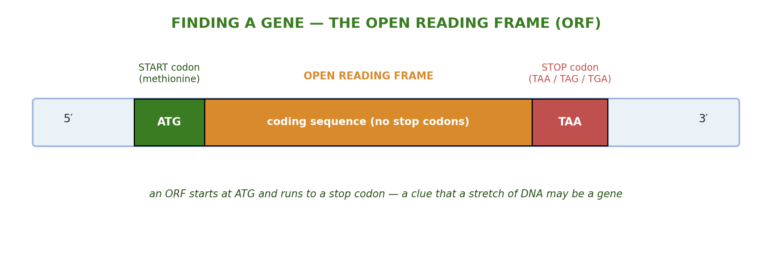
Figure 1: An open reading frame (ORF) - a run of DNA from a start codon (ATG) to a stop codon, with no stop codons in between.
The strand that reads the same as the mRNA is the sense (coding) strand; the other is the antisense (template) strand. An ORF alone does not prove a gene is present - long stretches without stop codons can occur by chance, and ATG also appears inside genes - but searching for ORFs highlights the regions worth investigating.
Why Six Reading Frames?
Because the bases are read in groups of three (codons), a single strand can be read in three different reading frames, depending on where you start. DNA has two strands, so a computer must translate and check 3 × 2 = 6 possible sequences to be sure it has not missed an ORF. The programs read each strand only in the 5′→3′ direction, because that is the direction in which transcription and translation actually occur.
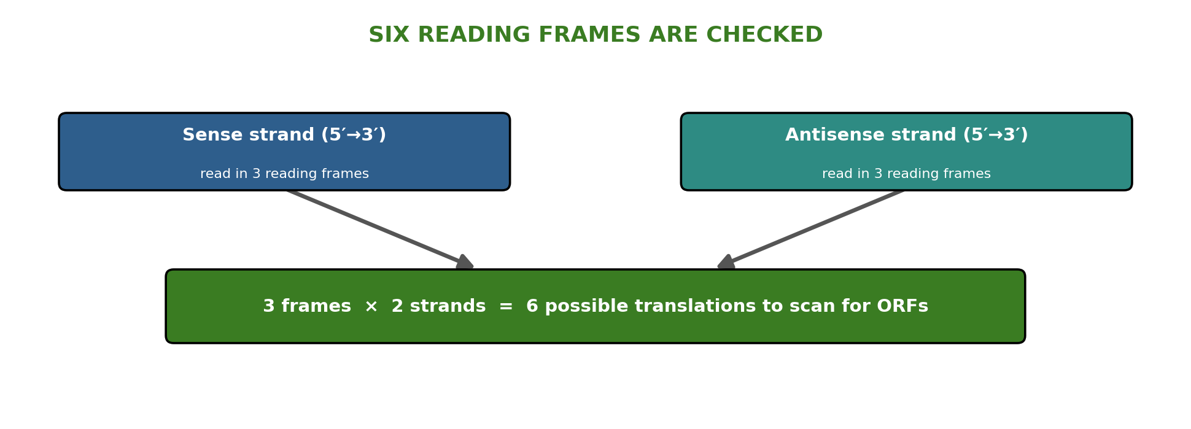
Figure 2: Three reading frames on each of the two strands give six translations to scan for ORFs.
Gene-finding is easier in bacteria, where genes are continuous (“beads on a string”), than in eukaryotes, whose genes are split into coding exons and non-coding introns (which contain internal stop codons). Alternative splicing - joining a gene's exons in different ways - is part of why humans make so many proteins from only about 25,000 genes.
Finding Functions: The BLAST Program
Once a sequence is assembled, BLAST (Basic Local Alignment Search Tool) is used to find out what it is. BLAST takes your unknown sequence - the query - and compares it, one at a time, to every sequence stored in a database, returning the closest matches first. If your unknown human sequence closely matches a known mouse gene for a salt-balance membrane protein, it is a good bet that the human sequence does the same job. This is how sequences from model organisms help reveal the function of new genes.
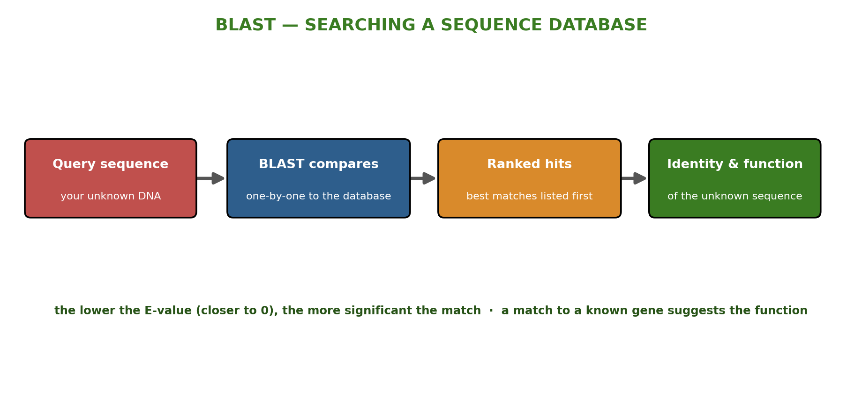
Figure 3: A BLAST search - the query sequence is compared to a database and the best-matching “hits” are ranked.

Reading a BLAST Result
- Sequence ID - a unique number identifying each database sequence.
- Description - the species the sequence comes from and the gene it is linked to.
- Query - how many bases are in your input sequence.
- Match - how well the query matches each hit (shown by shading).
- E-value - a measure of how significant a match is: the lower the E-value (closer to 0), the better the match; below 10⁻⁶ is biologically significant.
Examining Variation: The CLUSTAL Program
BLAST compares one sequence against a database. But scientists often want to compare several sequences at once to see where they are alike and where they differ. The CLUSTAL program produces such a multiple sequence alignment - it gets its name because it works with clusters of sequences. The sequences are lined up so that matching bases sit in the same column, making differences easy to spot.
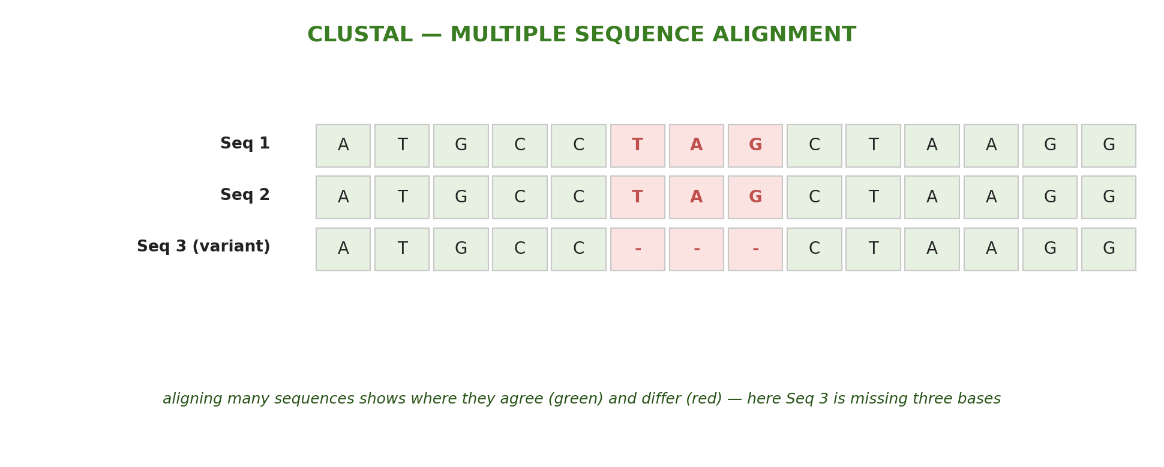
Figure 4: A CLUSTAL alignment - matching columns (green) show agreement; differences (red) stand out, here a three-base deletion.
CLUSTAL is used to examine genetic variation - for example, aligning a disease-linked gene from many people shows that a person with cystic fibrosis is missing a three-base sequence. It is also used to study evolution: aligning related sequences from different species lets another program calculate their relationships and draw an evolutionary tree.
Why This Matters
- Making sense of sequences - analysis turns raw DNA data into knowledge about genes and their functions.
- Medicine - comparing normal and disease versions of a gene identifies the changes that cause disease.
- Evolution & biodiversity - alignments reveal how species are related.
- Efficiency - computers analyse in minutes what once took years of laboratory work.
Worked Example - How Similar Are Two Sequences?
Two DNA sequences are each 20 bases long. Aligning them:
- If they match at 19 of the 20 bases (one difference), they are 19 ÷ 20 = 95% the same.
- If they match at 16 of the 20 bases (four differences), they are 16 ÷ 20 = 80% the same.
This is the idea behind statements such as “human and chimpanzee genomes are about 96% similar” - it is the percentage of positions that match when the sequences are aligned.
PNG Context Example
Sequence-analysis tools are freely available online, so students and scientists in Papua New Guinea can use BLAST to identify genes and pathogens, and CLUSTAL to compare strains of malaria, tuberculosis or plant pests. Because the analysis is done on a computer using public databases, these powerful methods are within reach of national universities and laboratories, connecting local research to the global scientific community.
References & Related Documents
Source Documents
- STEM Biology Student Resource Book - Grade 12, Term 1. Module 12.1 Bioinformatics, Topic 3: DNA Sequence Analysis (Finding Genes & Open Reading Frames; Finding Functions with BLAST; Examining Variation with CLUSTAL). Department of Education, PNG (2021).
- STEM Biology Syllabus - Grade 12, Term 1. Thema: Biotechnology; Module 12.1 Bioinformatics, Topic 3: DNA Sequence Analysis.
- Biology Standards-Based Syllabus, Grades 11 & 12 (PNG SBC 2020) - Strand 2: Life; investigate the structural properties of DNA and its role in heredity and protein synthesis.
Further Reading & References
- National Center for Biotechnology Information (NCBI) - BLAST. https://blast.ncbi.nlm.nih.gov
- EMBL-EBI - Clustal Omega (multiple sequence alignment). https://www.ebi.ac.uk/jdispatcher/msa/clustalo

